|  |
| --- |
| 1. WAQ to display second highest salary in HR schema. |

1. Java ArrayList

import java.util.ArrayList;

import java.util.Scanner;

public class Java_ArrayList {

public static void main(String[] args) {

Scanner sc = new Scanner(System.in);

int n = sc.nextInt();

ArrayList<ArrayList<Integer> > arr =

new ArrayList<ArrayList<Integer> >(n);

for(int i=0;i<n;i++) {

int num = sc.nextInt();

ArrayList<Integer> al= new ArrayList<Integer>();

for(int k=0;k<num;k++) {

al.add(sc.nextInt());

}

arr.add(al);

}

System.out.println("The output of the program is");

int k = sc.nextInt();

for(int i=0;i<k;i++) {

int p = sc.nextInt()-1;

int q = sc.nextInt()-1;

if(q>(arr.get(p).size()) - 1) {

System.out.println("ERROR!");

}

else {

System.out.println(arr.get(p).get(q));

}

}

}

} }

2.Java List

import java.util.ArrayList;

import java.util.Iterator;

import java.util.List;

import java.util.Scanner;

public class Java_List {

public static void main(String[] args) {

List<Integer> l1 = new ArrayList<>();

Scanner sc = new Scanner(System.in);

int n = sc.nextInt();

for(int i=0;i<n;i++) {

l1.add(sc.nextInt());

}

int a = sc.nextInt();

for(int i=1;i<=a;i++) {

String b = sc.next();

if(b.equals("Insert")) {

int p = sc.nextInt();

int q = sc.nextInt();

l1.add(p,q);

}

else {

int z = sc.nextInt();

l1.remove(z);

}

}

Iterator<Integer> iterate = l1.iterator();

while(iterate.hasNext()) {

System.out.print(iterate.next()+" ");

}

}

}

3.Java Map

import java.util.HashMap;

import java.util.Scanner;

public class Java_Map {

public static void main(String[] args) {

// TODO Auto-generated method stub

HashMap<String, Integer> h = new HashMap<>();

Scanner sc = new Scanner(System.in);

int n=sc.nextInt();

sc.nextLine();

for(int i=0;i<n;i++)

{

String name=sc.nextLine();

int phone=sc.nextInt();

sc.nextLine();

h.put(name,phone);

}

while(sc.hasNext())

{

String s=sc.nextLine();

try

{

int out=h.get(s);

System.out.println(s+"="+out);

}

catch(Exception e)

{

System.out.println("Not found");

}

}

}

}

SQL QUERIES;-

1.WAQ to display the second highest salary in HR schema

1. WAQ to display name of employee who is earning maximum in his/her department.

1. WAQ to display emplyees count who are working from same location.

1. WAQ to display number of employees joined year wise.

1. WAQ to top 2 earning employee name and salary in each department.

MCQS

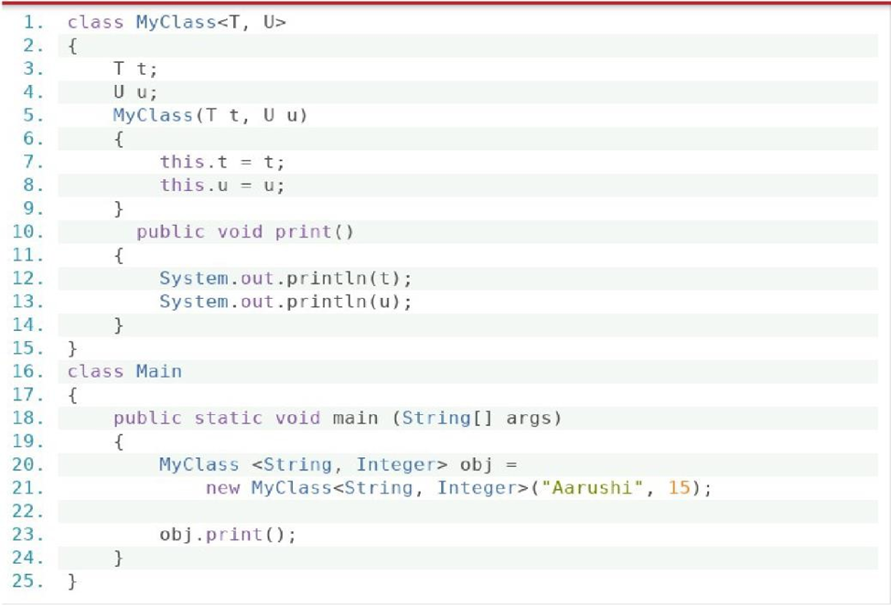

Output:

Aarushi 15

It will call print method then, String is taken as t and Integer is taken as u.

Output:

Set 1: [D,C,B,A]

Set 2: [E]

Set 3: [A,B,C,D,E]

Set 4: [A,B,C]

# **Of :** Creates an enum set initially containing the specified element.

**Complement.Of:** Creates an enum set with the same element type as the specified enum set initially it contains the elements which do not exist in the specified element.

**AllOf:** Creates an enum set containing all of the elements in the specified element type.

**Range:** Creates an enum set initially containing all of the elements in the range defined by the two specified endpoints.

Output:

Error,2

As due to infinite recursion it will full up the stack due to which compiler will show stack Overflow Error.

Answer:

You cannot specify which thread will get notified.

The event listener should hand off long tasks to another thread. Multithreading will help into multitasking and prevent the program to freeze.

The event listener should hand off long tasks to another thread. Multithreading will help into multitasking and prevent the program to freeze.

Output: 1

2

3

1

Output:

The program does not compile because this cannot be referenced in a static method.